Darkness Covers the People & Child Trafficking
November 16th, 2021

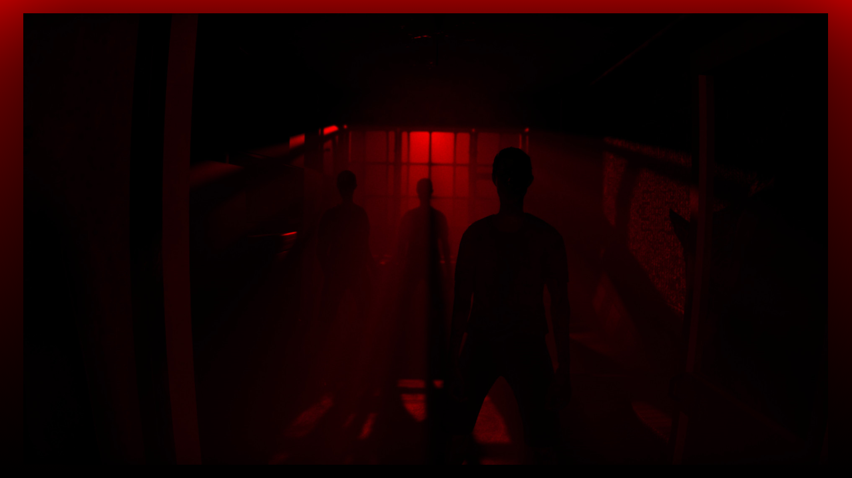
Oh Lord, enter into the territory of the wicked and unrighteous and with Your great mercy, move on their hearts and heal those who harm the innocent. Thank you for Your hedge of protection over the children and deliver them from all evil. Amen.

During the Resurrection decade of the Glorious Mysteries when it mentions the earth quakes as the angel rolls back the stone, the guards flee in terror due to God’s power. I saw the earth, that Blessed Mother was holding in her hands in a painting, and the earth started shaking violently and uncontrollably and then it stopped shaking but seemed to be still reeling from the after effects. I then heard Isaiah 60 verse 2, which reads, “See, darkness covers the earth and thick darkness is over the peoples, but the Lord rises upon you and His glory appears over you.”

Blessed Mother began speaking, “There are many who are living double lives. They say there are Christians and followers of My Son in the light of day, at church and charitable functions, but do unspeakable things that are hidden and done in darkness. Elisabeth, you and all my children, need to pray for these atrocities to end against the innocent, and for those who commit them to turn away from their sinful and wicked ways. Those covered in this filth must be shown the light and brought to My Son, repent and receive His great mercy.”

Just then, I saw a large, white, beautiful colonial styled house in an upper middle-class neighborhood. The family inside was just finishing dinner, the children were heading towards their video games and TV and the wife was clearing the dinner plates and bringing them into the kitchen. The well-dressed husband in a business suit was heading downstairs into the basement. There was a bookshelf against one wall that had a mechanism behind one of the books that opened up the entire bookshelf revealing a secret door. On the back of the secret door was sound proofing material and on the walls, ceiling and floor of this rather large room. Three children were there, two very young girls and a boy, ages five to seven, and they were chained to the floor. The vision ended with the feeling of fear and terror emanating from the children.

Mother Mary continued, “Those that perform wicked acts need your prayers. Most people do not have the courage to speak up when they become aware of the horrible doings of others. Their family members, friends, co-workers and employees who suspect or know about their evil deeds, say nothing and do nothing so as to not “rock the boat.” Wives are turning a blind eye to the detestable and unimaginable, abhorrent behavior of their husbands because they do not want to lose their comfortable lifestyles, their status in social circles and at their country clubs.

“My children, sin must be recognized and brought into the open for healing and redemption to begin to take root. I would like all of you to give up something this week that you would normally enjoy for the salvation of these souls and for protection over their innocent victims. They have no one to pray for them, please set aside your human emotions of horror and disgust and pray for these souls to be pulled out of the darkness and their twisted by Satan mindset and help bring them to the mercy seat of divine love.”

Mother Mary began speaking to Mother Clare, “This day that you spent exhausted, was most certainly intercession for the children trapped in this horrible system of child sacrifice to obtain their life force.”

“Oh Mother, when will this be brought to an end.”

“Unfortunately, it will get much worse before it gets better.”

“It is so heart breaking…and where is President Trump? Seems like he just opened the can of worms and now it is so much worse.”

“Nothing of any great stature will get done until My Son returns. It will continue to get darker and darker. Your prayers do have a substantial impact on these little ones. You know how the mercy of God is. Would you like me to tell you how He is handling this?”

“Yes, please.”

Blessed Mother continued, “They are taken out of their bodies Clare, they can see what is going on but they feel nothing. The body however does respond to the pain, but they are removed from the body. The difficult part is when they come back to themselves, they suffer terribly. You see, all these little ones made an agreement at their assignment to a body, that they would offer themselves as victims for the cruelties of the human race and in time they would be permanently lifted out of their bodies to be with God in Heaven forever.

“They come from every tribe and nation, and each is a living holocaust for civilization and mankind. Their eternity in Heaven will be unlike any other. They will remember nothing from their lifetime here, and they will overflow with blissful happiness for all eternity. Some will join the choirs of Heaven to sing, others will abide in a place of extreme happiness with other children, and nothing will be denied them.

“For a little season of terrible suffering on earth, their eternity is guaranteed, in the most blissful places forever. There are so many things you do not understand about these relationships and how souls come to understand their quickly passing part in this wicked world.”

The blessed Mother had a little child by the hand. She was blond with curly hair and perfect blue eyes, she had been completely redeemed and restored and had no recollection of her lifetime on earth. She was bubbly and her eyes sparkled with joy. She was perfect to look at and seemed supernaturally filled with effervescent life.

“You will see many such as these when you come here. And it will be impossible to tell the difference between who was ritualistically killed, and who was not, so thorough will be their healing and restoration.

“Oh do pray Clare, and all my children! Pray so very hard for these little ones, what they have gone through is so very terrible. Their reward is perpetual joy beyond anything we can measure and they are deeply in love with My Son. Their worship is so pure that it puts Him in an ecstasy when they open their little mouths to sing. It will do quite the same for you when you come here.”

“When Mother? When? Oh Mother, I will be so glad when this is over, once and for all, over.”

“Time is closing in on the reality of the end, time is closing in. Please look to me for help Clare and all my children. Please come to me knowing I will not leave you without help. What you are living through is only a taste of what is yet to come. But I promise you, you will be taken out up and away very soon, time is closing in, you haven’t long to wait.”

